Uzma Usmani 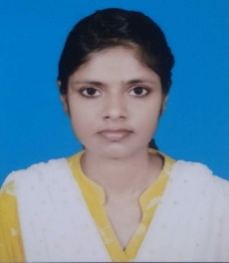

* Contact: +91-8709266064
* Godda, Jharkhand
* Email: uzmausmani0143@gmail.com
* Linkedin: https://www.linkedin.com/in/uzma-usmani-21b524168/

Objective

* To secure a challenging position in a reputable organization to expand my learning knowledge and skill.
* I'm looking for a job where I can develop my skill in work, that can encourage teamwork and team projects specially in IT Industry because it offers quick employment and opportunities in every sector,multiple career paths and high salaries.

Technical Skills

Linux | HTML5 | Cascading Style Sheets (CSS) | JavaScript | Bootstrap | SQL | Software Development Life Cycle (SDLC) | Python

Work Experience

Data Entry Typist

Sri Publication & Stationers Pvt. Ltd., Jharkhand

Mar 2016 - Jun 2019

Education

* Bachelor in Arts: English Hons. - 55.8%

Tilka Manjhi Bhagalpur UniversityJun (2013 - Jun 2016)

* I.Sc: Science - 62.4%

Mahila Mahavidyalaya,Godda,Jharkhand (Aug 2011 - May 2013)

* Matriculation - CGPA: 8.4

Millia Convent English School,,Purnea, Bihar (Apr 2009 - Mar 2011)

Certifications

* Enterprise Design Thinking Practioner (Oct 2022 - Oct 2022)
* Red Hat Linux Technical Overview (Nov 2022 - Nov 2022)

Languages

* English
* Hindi

Hobbies and Interests

* Cooking
* Surfing Net
* Playing Chess
* Self-learning through Internet

Other Information

* Expected Salary: As per company standards
* Area of Interest: Software Development, Programming, Start-ups & Coding

Declaration

I hereby declare that the details furnished above are true and correct to the best of my knowledge and belief.